**Use logo in smartforms**

1. Go to tcode smartforms
2. Select the Radiobutton Form. Give name starting with Z/Y. Click on create

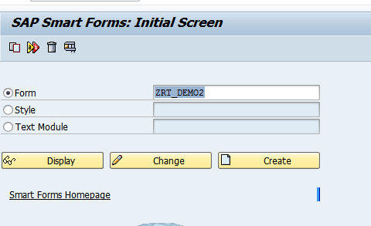

1. Expand Pages and windows folder.

Right click on First Page-Create-Window

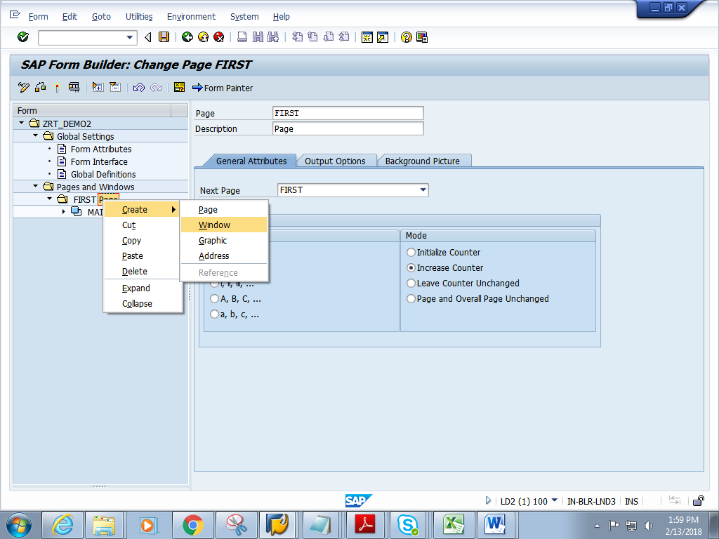

1. Give short description and name.

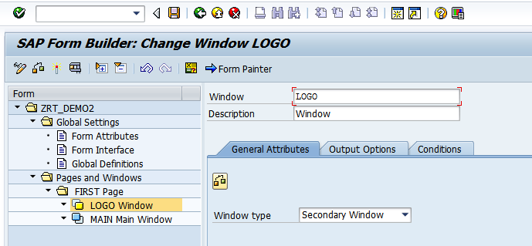

5) Right click on LOGO window. Create-Graphic

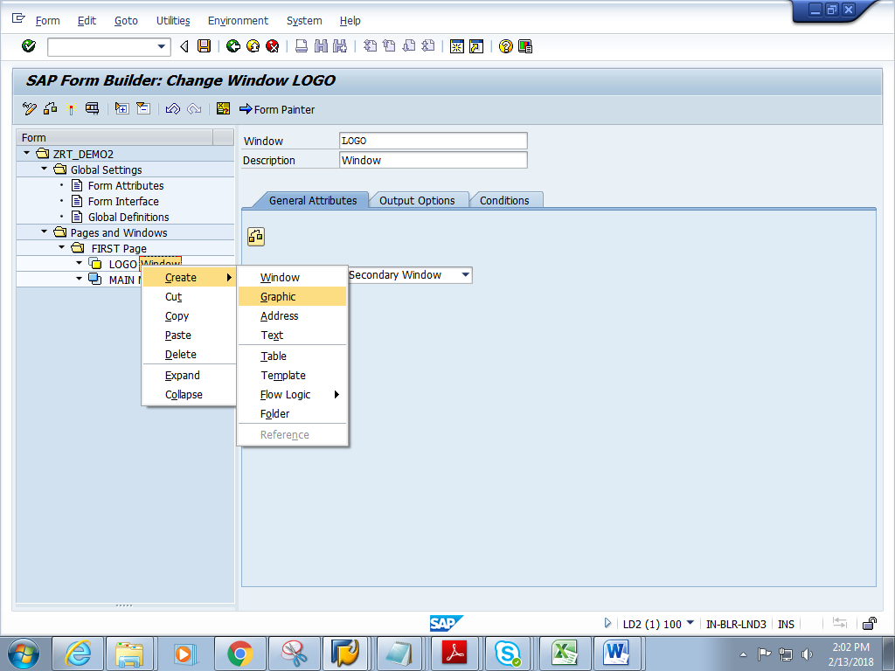

6) Click F4 on Name.

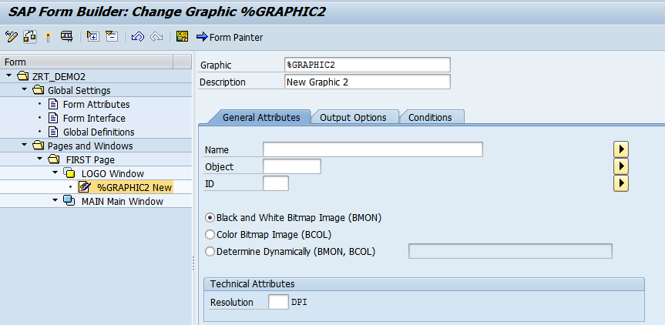

7) Check on Color Bitmap and click on execute.

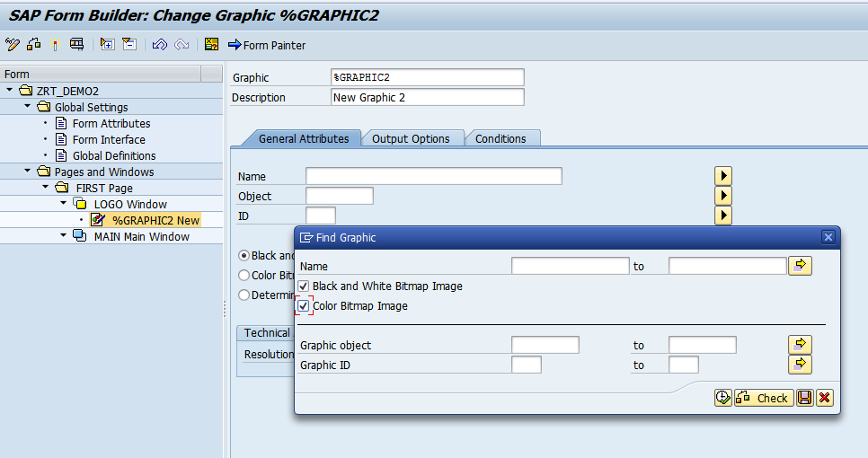

8) Choose any image (eg.enjoy)and click execute.

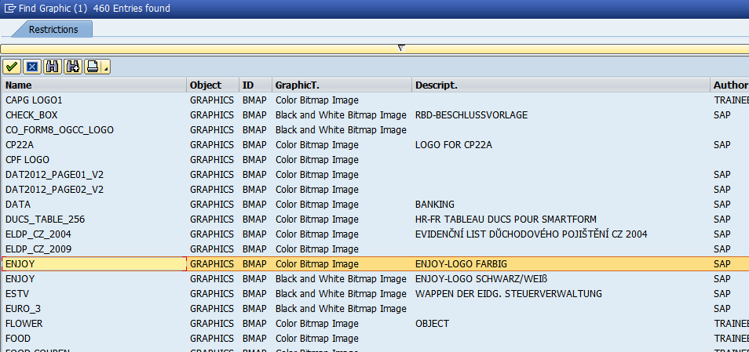

9) Give resolution as 150.

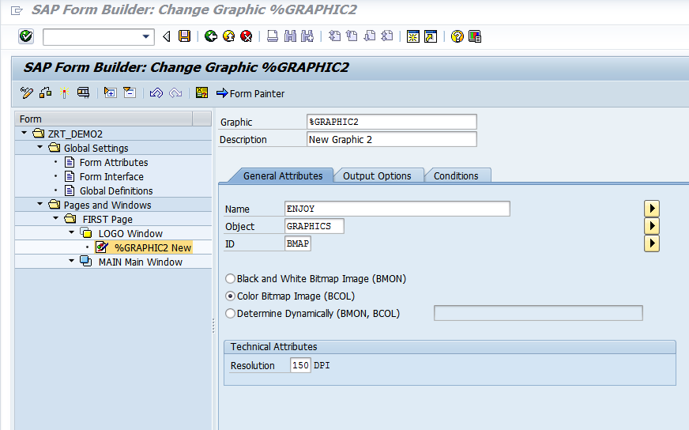

10 ) Click on Form Painter. Adjust the logo by dragging the Logo Window to the centre of the page.

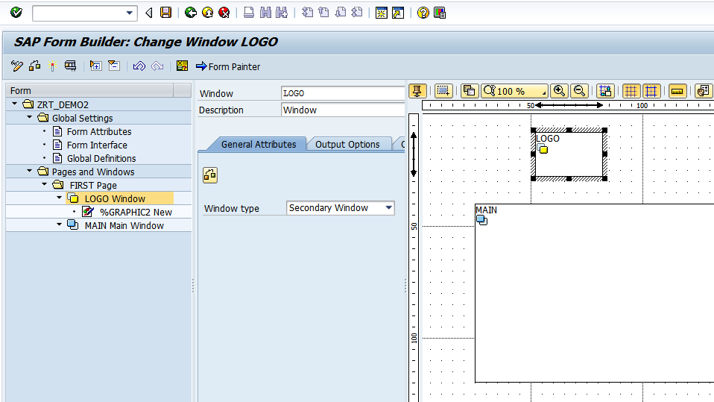

11) Save and activate the form.

12) Execute the form .Execute the function module

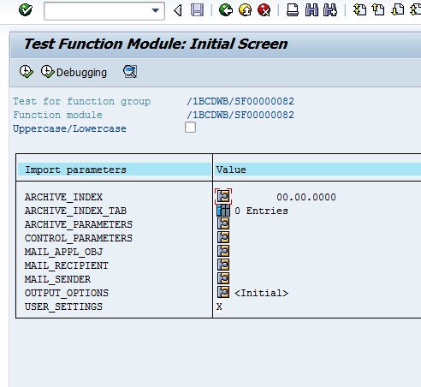

13) Click on Print preview

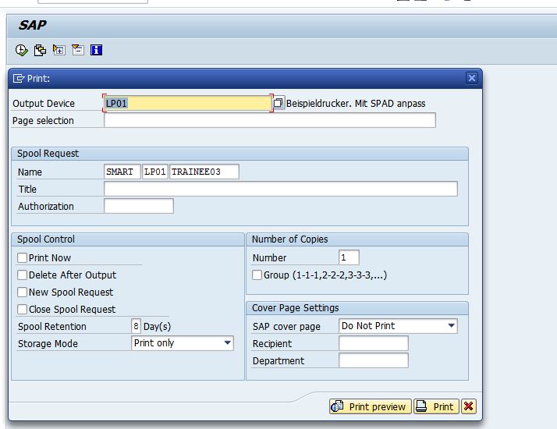

14) Expected output is as follows.

